***Compiler Design - Week 3***

1. Write a lex program to match any string of one or more digits with

an optional prefix of + (or) -

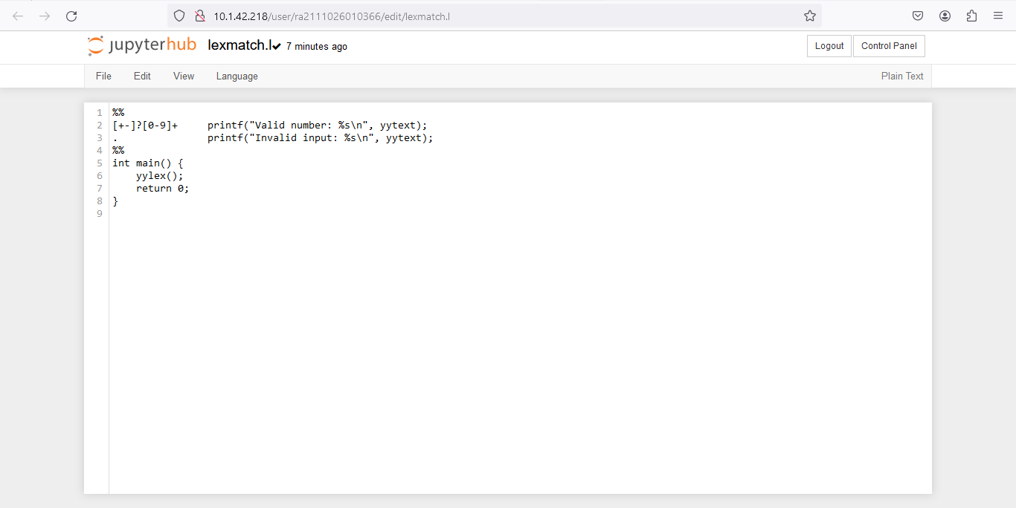

2. Regular Expression for unsigned number. To write a lex program to identify

whether given number is unsigned or not.  
  
Regular Expression - [0-9]+

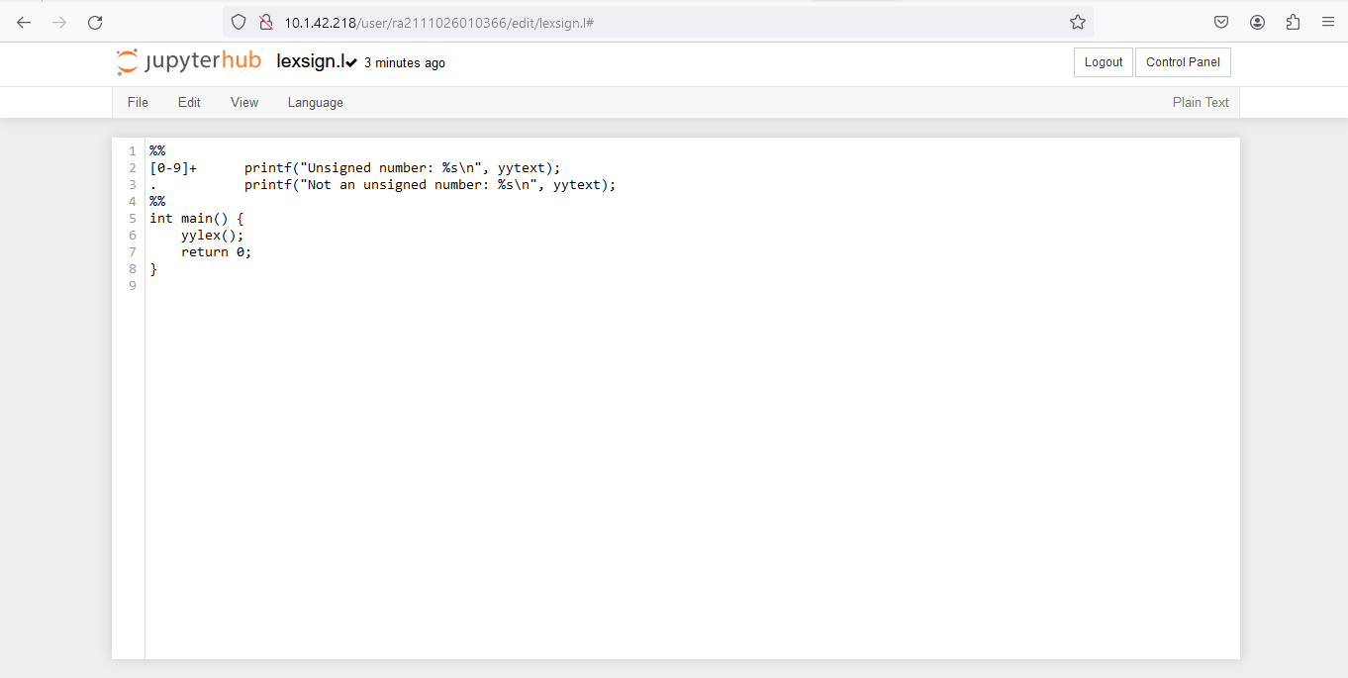

3. Conversion from Regular Expression to NFA

## Algorithm for the conversion of Regular Expression to NFA

**Input** − A Regular Expression R

**Output** − NFA accepting language denoted by R

**Method**

For ε, NFA is



For a NFA is

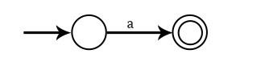

For a + b, or a | b NFA is

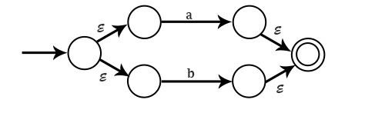

For ab, NFA is



For a*, NFA is

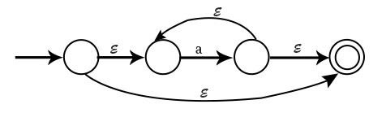

**Example1** − Draw NFA for the Regular Expression a(a+b)*ab

**Solution**

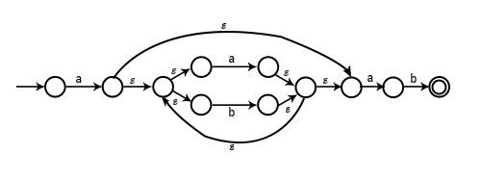

4. Conversion from NFA to DFA

## Steps for converting NFA to DFA:

Step 1: Convert the given NFA to its equivalent transition tableTo convert the NFA to its equivalent transition table, we need to list all the states, input symbols, and the transition rules. The transition rules are represented in the form of a matrix, where the rows represent the current state, the columns represent the input symbol, and the cells represent the next state.

Step 2: Create the DFA’s start stateThe DFA’s start state is the set of all possible starting states in the NFA. This set is called the “epsilon closure” of the NFA’s start state. The epsilon closure is the set of all states that can be reached from the start state by following epsilon (?) transitions.

Step 3: Create the DFA’s transition tableThe DFA’s transition table is similar to the NFA’s transition table, but instead of individual states, the rows and columns represent sets of states. For each input symbol, the corresponding cell in the transition table contains the epsilon closure of the set of states obtained by following the transition rules in the NFA’s transition table.

Step 4: Create the DFA’s final statesThe DFA’s final states are the sets of states that contain at least one final state from the NFA.

Step 5: Simplify the DFAThe DFA obtained in the previous steps may contain unnecessary states and transitions. To simplify the DFA, we can use the following techniques:

* Remove unreachable states: States that cannot be reached from the start state can be removed from the DFA.
* Remove dead states: States that cannot lead to a final state can be removed from the DFA.
* Merge equivalent states: States that have the same transition rules for all input symbols can be merged into a single state.

Step 6: Repeat steps 3-5 until no further simplification is possibleAfter simplifying the DFA, we repeat steps 3-5 until no further simplification is possible. The final DFA obtained is the minimized DFA equivalent to the given NFA.

Example**:** Consider the following NFA shown in Figure 1.

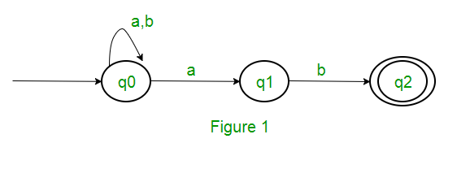

Following are the various parameters for NFA. Q = { q0, q1, q2 } ? = ( a, b ) F = { q2 } ? (Transition Function of NFA)

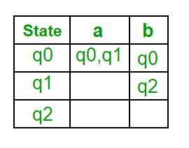

Step 1: Q’ = ? Step 2: Q’ = {q0} Step 3: For each state in Q’, find the states for each input symbol. Currently, state in Q’ is q0, find moves from q0 on input symbol a and b using transition function of NFA and update the transition table of DFA. ?’ (Transition Function of DFA)

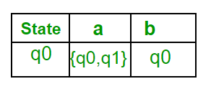

Now { q0, q1 } will be considered as a single state. As its entry is not in Q’, add it to Q’. So Q’ = { q0, { q0, q1 } } Now, moves from state { q0, q1 } on different input symbols are not present in transition table of DFA, we will calculate it like: ?’ ( { q0, q1 }, a ) = ? ( q0, a ) ? ? ( q1, a ) = { q0, q1 } ?’ ( { q0, q1 }, b ) = ? ( q0, b ) ? ? ( q1, b ) = { q0, q2 } Now we will update the transition table of DFA. ?’ (Transition Function of DFA)

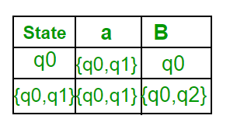

Now { q0, q2 } will be considered as a single state. As its entry is not in Q’, add it to Q’. So Q’ = { q0, { q0, q1 }, { q0, q2 } } Now, moves from state {q0, q2} on different input symbols are not present in transition table of DFA, we will calculate it like: ?’ ( { q0, q2 }, a ) = ? ( q0, a ) ? ? ( q2, a ) = { q0, q1 } ?’ ( { q0, q2 }, b ) = ? ( q0, b ) ? ? ( q2, b ) = { q0 } Now we will update the transition table of DFA. ?’ (Transition Function of DFA)

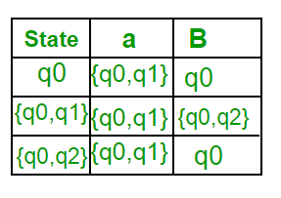

As there is no new state generated, we are done with the conversion. Final state of DFA will be state which has q2 as its component i.e., { q0, q2 } Following are the various parameters for DFA. Q’ = { q0, { q0, q1 }, { q0, q2 } } ? = ( a, b ) F = { { q0, q2 } } and transition function ?’ as shown above. The final DFA for above NFA has been shown in Figure 2.

